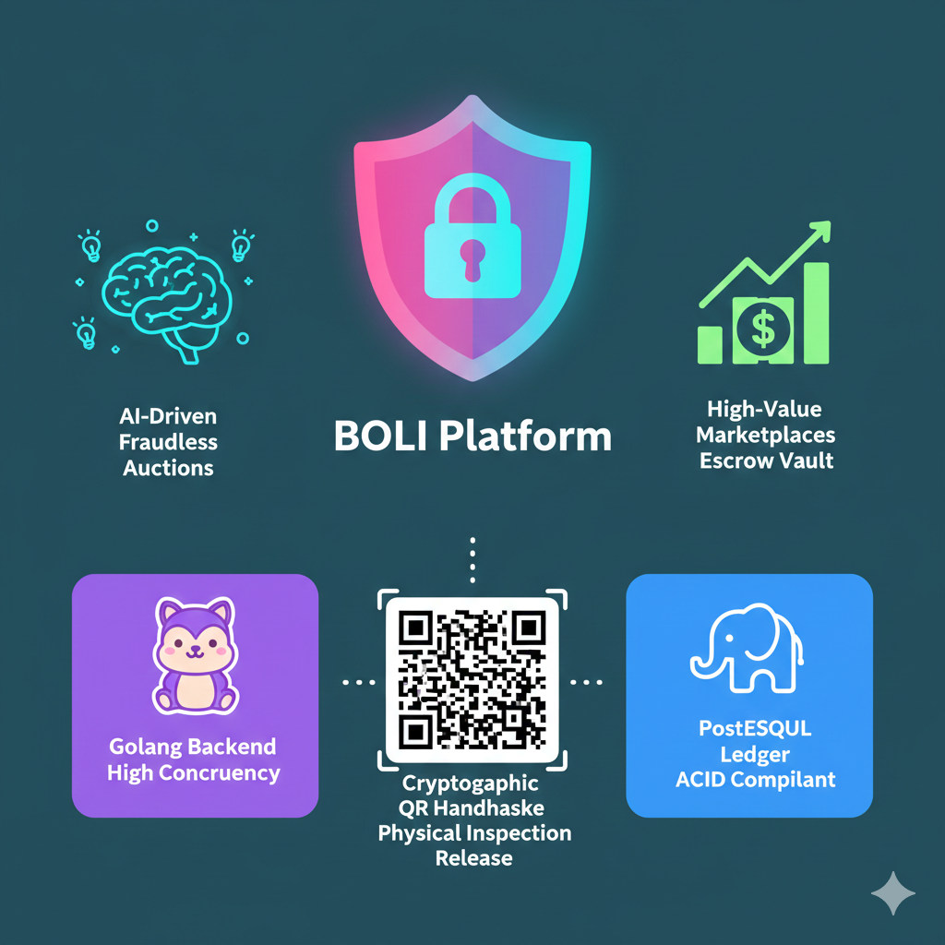
Arham Jan & Abdul Qayyum
01-131232-013 & 01-131232-003
Abstract
Boli is a "trustless," AI-driven escrow auction platform designed to eliminate fraud in high-value C2C marketplaces. Powered by a high-concurrency Golang backend and an ACID-compliant PostgreSQL ledger, winning bids are locked in an automated escrow vault and released strictly via a cryptographic QR handshake upon successful physical inspection.
Boli
Project Proposal

1. Introduction
1.1 Purpose:
Buying high-value assets on traditional classifieds exposes users to severe risks of fraud, counterfeit currency, and unsafe physical meetups. Boli is a "trustless," AI-driven C2C auction platform that eliminates these dangers by replacing blind trust with an unbreakable digital escrow system. By enforcing a zero-sum financial ledger, buyers can only place bids using pre-verified digital funds, guaranteeing authentic demand and instantly filtering out scammers. When an auction concludes, the winning funds are autonomously locked in an escrow vault prior to the physical meetup. The transaction is only finalized when the buyer inspects the item in person and scans the seller's cryptographic, Two-Phase Commit (2PC) QR code to release the funds. Powered by a high-concurrency Golang backend and an ACID-compliant PostgreSQL database, Boli completely decouples financial risk from the physical asset transfer, creating a guaranteed, anxiety-free secondary market.
1.2 Problem Statement:
While traditional classified platforms, such as OLX and Facebook Marketplace, have successfully democratized consumer-to-consumer (C2C) commerce, they operate merely as digital bulletin boards. They connect buyers and sellers but completely abandon them during the most critical phase: the financial and physical exchange. This lack of transactional infrastructure creates a high-friction, high-risk environment, particularly when trading expensive assets like used electronics, smartphones, and vehicles.
Currently, the C2C ecosystem is plagued by severe vulnerabilities that heavily limit market liquidity:
- The Anxiety of Physical Meetups: Carrying hundreds of thousands of rupees in physical cash to meet a stranger in an uncontrolled environment poses a severe personal security risk to the buyer.
- The Threat of Counterfeit Currency & Fraud: Sellers operate under the constant threat of receiving forged banknotes or falling victim to sophisticated proof-of-payment scams, forcing them to become amateur fraud detectives.
- Bad-Faith Negotiation & Last-Minute Haggling: Because there is no binding financial commitment prior to the meetup, the market is saturated with non-serious buyers. This leads to rampant "ghosting" and the toxic practice of last-minute haggling, where buyers attempt to renegotiate mutually agreed-upon prices at the point of physical handover.
Ultimately, the traditional C2C market forces users to rely entirely on blind human trust. Because the financial risk is deeply entangled with the physical transfer of the asset, users often avoid selling high-value items online altogether, resulting in an inefficient and unsafe secondary market.
1.3 Proposed Solution:
To resolve the critical vulnerabilities of the traditional C2C market, Boli transitions the ecosystem from a passive digital bulletin board into a highly regulated, mathematically enforced state machine. The system completely decouples financial risk from the physical handover by routing every transaction through a strict four-phase technical lifecycle:
Phase 1: Regulatory Onboarding & NTN Verification
Before a user can fund their wallet, place a bid, or create a listing, Boli enforces a strict regulatory firewall at the account creation level.
- Users must complete a mandatory Know Your Customer (KYC) flow by providing a valid CNIC and NTN (National Tax Number), establishing the verified root identity for their account.
- The backend uses this NTN to dynamically categorize the user's tax status as either an "Active Taxpayer" (Filer) or "Non-Filer" within the database.
- This pre-verification is mathematically required by the Boli ledger to autonomously calculate the exact, legally mandated FBR withholding tax deductions that will occur during the final escrow settlement phase.
Phase 2: Dynamic Ingestion & AI Verification
Unlike traditional platforms that rely on blind user inputs, Boli enforces structural integrity at the point of listing.
- When a seller uploads an asset, the system utilizes dynamic JSONB metadata schemas to adapt to the specific category (e.g., requiring IMEI numbers for smartphones or VINs for vehicles).
- Before the listing goes live, isolated Python-based AI microservices scan the uploaded imagery and documentation. This automated vetting process verifies the physical existence of the item, extracts text via OCR to match against user KYC data, and assigns a baseline risk score, ensuring fraudulent or non-existent items never reach the market.

Phase 3: Zero-Sum Bidding & The Proof of Funds Gateway
Boli entirely eliminates bad-faith negotiation, last-minute haggling, and "ghosting" by enforcing a strict "Proof of Funds" constraint at the API gateway level.
- The platform operates on a closed-loop digital wallet system backed by an ACID-compliant PostgreSQL database.
- When a buyer attempts to place a bid on an active auction, the Golang-powered backend intercepts the request and queries the user's Available_Balance. If the exact integer value of the bid does not exist in the wallet, the request is instantly rejected.
- This guarantees 100% market liquidity; every single bid on the platform is mathematically backed by real, pre-verified funds, ensuring sellers only interact with highly capable, serious buyers.
Phase 4: The Autonomous Escrow Vault
To neutralize the threat of counterfeit currency and physical robbery, no physical cash is permitted at the point of exchange.
- The moment an auction concludes, the system's ledger executes a state transition. The winning bid amount is autonomously deducted from the buyer's active wallet and locked within Boli’s internal Escrow Vault (Escrow_Liability).
- The money is now held strictly by the system's mathematical constraints. The seller travels to the physical meetup knowing with absolute certainty that the funds are secured, while the buyer travels knowing their money cannot be stolen.
Phase 5: Cryptographic Settlement (The 2PC QR Handshake)
The actual physical handover is governed by a strict Two-Phase Commit (2PC) protocol to ensure neither party can exploit the other.
- At the physical meetup, the buyer inspects the asset. If the item matches the description and passes inspection, the buyer utilizes the Boli application to scan a unique, time-sensitive cryptographic QR code generated on the seller’s device.
- Phase 1 (Validation): The scan sends a cryptogram to the backend, verifying the unique cryptographic seed matches the locked escrow ID. The system calculates the platform fee and mandatory withholding taxes.
- Phase 2 (Execution): The system instantly releases the escrowed funds, routing the exact owed amount into the seller's available wallet balance and isolating the tax deductions into Boli's internal master wallets.
Through this enforced architecture, Boli guarantees that the buyer does not release funds until the item is physically verified, and the seller does not hand over the item until the digital payment is mathematically cleared.
1.4 Project Scope:
This project focuses on the design, architecture, and implementation of the Minimum Viable Product (MVP) for the Boli platform. The scope strictly defines the boundaries of the system to ensure the successful delivery of the core "trustless" escrow and bidding engines.
In-Scope (System Capabilities):
- User & Wallet Management: Development of an internal, closed-loop digital wallet system where user balances (simulated fiat) are managed entirely within an ACID-compliant PostgreSQL database.
- Dynamic Listing & AI Vetting: Implementation of flexible JSONB schemas for varied asset categories and integration of a Python-based AI microservice to simulate image vetting, OCR extraction, and risk scoring.
- Real-Time Bidding Engine: A high-concurrency, Golang-powered WebSocket gateway capable of broadcasting state changes and validating "Proof of Funds" in real-time.
- Escrow State Machine: The mathematical locking and routing of funds during an active transaction, including the calculation of internal platform fees and simulated FBR withholding taxes.
- Cryptographic Settlement: The generation and validation of the Two-Phase Commit (2PC) QR code handshake required to release escrowed funds upon physical meetup.
Out-of-Scope (System Boundaries):
- Live Banking Integration: Direct API integration with national payment gateways (e.g., Raast, 1Link, JazzCash, Kuickpay) is out of scope due to SECP corporate requirements. Fiat ingestion and extraction will be managed via a simulated "Admin Funding" module to prove the ledger's mathematical integrity.
- Live Government Databases: Direct API connections to live governmental nodes (e.g., NADRA for biometric KYC, Excise & Taxation for MTMIS vehicle verification, or FBR for live tax remittance) are out of scope. To demonstrate decoupled microservice architecture, these external dependencies will be fulfilled using internal Mock APIs that adhere strictly to industry-standard JSON contracts.
- Logistics & Shipping: The Boli MVP is strictly designed for local, in-person physical handover. Features related to courier integrations, shipping tracking, or long-distance logistics are excluded from this phase.

2. Target Audience & Market Impact
2.1 Target Users:
Boli is exclusively designed for legally identifiable participants in the secondary market trading high-value physical assets, where the financial risk of fraud outweighs the convenience of traditional classifieds. Due to the fact that the platform enforces strict KYC and NTN verification, the user base is curated for serious transactions. The architecture targets three primary segments:
- University Students & Young Professionals:
This demographic frequently cycles through expensive, highly liquid electronics (e.g., MacBooks, iPhones, DSLRs). For a student, a Rs. 150,000 to Rs. 300,000 transaction represents a massive financial stake. Boli provides this financially vulnerable group with a mathematically secure way to upgrade their gear without the anxiety of meeting strangers with physical cash.
- Automotive Buyers & Sellers (C2C):
Individuals trading used cars and motorcycles. This specific market suffers heavily from "token money" fraud, forged bank drafts, and the physical danger of large cash handovers. Boli targets these users by guaranteeing that the buyer actually possesses the millions of rupees required before a test drive or meetup is even scheduled.
- Tech Freelancers & Hardware Enthusiasts:
Professionals who need a liquid, secure secondary market to offload expensive specialized equipment. These users value efficiency and are deeply frustrated by the time-wasting "ghosting" and lowballing prevalent on anonymous platforms. Boli’s Proof of Funds requirement ensures they only interact with verified, financially capable buyers.
2.2 Business Value:
The traditional C2C market for high-value goods is severely bottlenecked by fear. Millions of rupees in potential transactions are abandoned daily because individuals are unwilling to risk physical safety or financial fraud by meeting strangers with cash. Boli.pk directly monetizes the removal of this fear.
By guaranteeing the transaction mathematically rather than relying on human trust, Boli unlocks a massive, previously dormant segment of the secondary market. The business impact is twofold:
- Increased Market Liquidity: Sellers who previously avoided platforms like OLX for high-end items (e.g., Rs. 300,000 laptops, Rs. 4,000,000 cars) will utilize Boli due to the guaranteed Proof of Funds and autonomous Escrow Vault. Buyers will confidently participate knowing they cannot be scammed by counterfeit products, as their money is mathematically protected until physical inspection.
- Direct Revenue Generation: Because Boli completely secures the transaction, it justifies a micro-transactional revenue model. The platform generates revenue by capturing a strict, automated percentage fee (e.g., 1% to 2.5%) executed during the final Phase 5 QR settlement, safely deducting the platform fee alongside mandatory FBR taxes before transferring the balance to the seller.
Ultimately, Boli transitions C2C classifieds from a high-risk gamble into a highly secure, regulated, and profitable fintech ecosystem.

3. High-Level Requirements
3.1 Functional Requirements:
The Boli system is driven by five core operational engines, each responsible for a distinct phase of the transaction lifecycle:
- Regulatory Onboarding Engine:
The system must securely ingest and validate user CNIC and NTN data to dynamically assign FBR tax brackets (Filer vs. Non-Filer) upon account creation.
- Dynamic Asset Vetting:
The platform must utilize AI microservices to analyze user-uploaded images and metadata, assigning a baseline risk score to prevent fraudulent or non-existent items from being listed.
- Zero-Sum Bidding Gateway:
The backend must intercept every incoming bid to verify the user's Available_Balance in real-time. If the funds are insufficient, the system must mathematically reject the bid to guarantee market liquidity.
- Automated Escrow Ledger:
Upon auction completion, the system must autonomously deduct the winning bid from the buyer's wallet and lock it securely within an internal Escrow Liability state..
- Cryptographic Settlement Protocol:
The application must generate and process a Two-Phase Commit (2PC) QR code handshake at the physical meetup, triggering the final release of funds to the seller and withholding the required platform/tax fees.
3.2 Non-Functional Requirements:

To guarantee financial immutability and high-velocity trading, the system architecture must strictly adhere to the following constraints:
- Concurrency & Scalability (C10K Ceiling):

The Golang backend must be capable of sustaining 10,000+ simultaneous WebSocket connections to manage real-time auction arrays without bottlenecking or dropping active bids.
- Data Integrity (ACID Compliance):

The PostgreSQL database must enforce strict Double-Entry accounting principles. System states must be transactional; a failure at any point in the fund transfer process must result in a complete database rollback.
- Latency Thresholds:

Bid placement, wallet verification, and state broadcasting must execute in under 50 milliseconds to ensure real-time synchronization across all connected clients.
- Security & Cryptography:

The QR codes used for physical settlement must be dynamically generated, cryptographically signed, and highly time-sensitive (e.g., 60-second Time-To-Live) to prevent screenshotting or replay attacks.
- Regulatory Retention:

The database must maintain a 5-year immutable audit trail of all completed transactions, escrow locks, and tax withholdings to satisfy potential external regulatory inquiries.

4. System Architecture & Methodology
4.1 Technology Stack:
To achieve the high concurrency, financial immutability, and automated vetting required by the Boli platform, the system architecture is decentralized into purpose-built microservices.
- Backend Gateway & WebSocket Engine: Golang (Go)
  - Justification: Traditional single-threaded environments (like Node.js) struggle under heavy WebSocket loads. Golang was selected for its native concurrency model (goroutines and channels). This allows the backend to efficiently maintain thousands of persistent, real-time WebSocket connections (the C10K ceiling) during live auctions without blocking the main execution thread or consuming excessive memory.
- Financial Ledger & State Storage: PostgreSQL
  - Justification: Due to the fact that Boli operates a zero-sum digital wallet and escrow system, strict ACID (Atomicity, Consistency, Isolation, Durability) compliance is non-negotiable. PostgreSQL ensures mathematical immutability through transaction rollbacks (e.g., if an escrow lock fails, the entire transaction reverts). Furthermore, PostgreSQL's native JSONB support allows for dynamic, schema-less metadata storage for varying asset categories (e.g., storing a car's VIN vs. a phone's IMEI in the same table).
- AI & Vetting Microservice: Python
  - Justification: Python serves as an isolated microservice dedicated strictly to computational analysis. It utilizes standard machine learning and computer vision libraries (e.g., OpenCV, TensorFlow) to process user-uploaded imagery, perform OCR (Optical Character Recognition) for KYC/NTN data extraction, and assign baseline fraud-risk scores before listings are published to the Golang gateway.
- Client-Side Application: React / React Native
  - Justification: To facilitate the complex UI state management required for live bidding timers, dynamic wallet balances, and the Phase 5 Cryptographic QR handshake (camera integration), React provides a highly responsive, component-driven frontend architecture.

4.2 Development Methodology:
The development of the Boli MVP will be governed by an Agile software engineering framework. Given the complex, high-risk nature of integrating a concurrent WebSocket bidding engine with a zero-sum financial ledger, a rigid Waterfall approach is unsuitable. Agile facilitates continuous integration, rigorous testing, and adaptive architecture.
- Iterative Sprints: The project will be modularized into distinct development sprints. This allows the engineering team to isolate and finalize core microservices—such as securing the PostgreSQL wallet architecture and testing state rollbacks—before attaching the Golang WebSocket gateway or the Python AI services.
- Continuous Integration & Financial Testing: Because the system programmatically controls simulated financial balances and FBR tax withholding logic, Test-Driven Development (TDD) principles will be heavily prioritized. Every mathematical state transition (e.g., moving an integer from Available_Balance to Escrow_Liability) will be rigorously tested in isolation to prevent ledger corruption.
- Adaptive Architecture: The Agile framework ensures that the team retains the flexibility to pivot technical implementations during the development lifecycle. If the Two-Phase Commit (2PC) QR handshake requires latency optimization, or if the Python OCR schemas need adjustment for different asset categories, Agile allows for these refinements without derailing the overarching project structure.

5. Risk Management
5.1 Technical Risks:
Given the high-stakes financial nature of the platform, the architecture anticipates several critical points of failure. The following technical risks have been identified, alongside their engineered mitigations:
- WebSocket Disconnection During Live Auctions:
  - The Risk: In a real-time bidding environment, a client's network connection might drop milliseconds before an auction closes, causing them to miss a critical bid.
  - The Mitigation: The React frontend will implement an aggressive auto-reconnection and heartbeat ping protocol. Concurrently, the Golang backend will utilize timestamped bid queues, ensuring that even if a connection flickers, any payload successfully reaching the gateway before the epoch cutoff is mathematically processed and broadcasted to all active listeners.

- Ledger Corruption & Mid-Transaction Server Crashes:
  - The Risk: If the backend server crashes exactly as funds are moving from Available_Balance to Escrow_Liability, the digital ledger could become unbalanced, "destroying" or duplicating simulated fiat.
  - The Mitigation: Complete reliance on PostgreSQL's ACID properties. Every financial state transition is wrapped in a strict database transaction block (BEGIN, COMMIT, ROLLBACK). If the logic fails at any microsecond before the final commit, the database automatically rolls back to the previous stable state, guaranteeing zero-sum integrity.

- AI Microservice False Positives/Negatives:
  - The Risk: The Python-based AI vetting microservice may fail to properly extract OCR data from a valid CNIC/NTN, or it might incorrectly flag a legitimate asset listing as fraudulent due to poor image lighting.
  - The Mitigation: The AI is designed as a confidence-scoring engine, not a final executioner. If the risk assessment confidence score falls below a defined threshold (e.g., 85%), the system will not auto-reject the user; instead, it will dynamically route the payload to an "Admin Pending" state for manual override, preventing user lockouts.

- Physical Meetup Connectivity Failures (2PC QR Scan):
  - The Risk: The buyer and seller meet in a location with poor cellular reception (e.g., an underground parking garage), preventing the Phase 5 QR handshake from reaching the Golang gateway to release the escrowed funds.
  - The Mitigation: The system architecture enforces that the cryptographic QR seed generated on the seller's device has a defined Time-To-Live (TTL). If the API call fails due to network timeouts, the app clearly displays a "Pending Network State," and the buyer must move to a connected area to complete the transmission. Funds remain mathematically locked in escrow until the backend successfully validates the cryptogram.

5.2 Security & Fraud Risks:
As a platform handling zero-sum financial states and simulated fiat, Boli is a high-value target for exploitation. The architecture is explicitly designed to neutralize the following security and fraud vectors:
- Shill Bidding & Market Manipulation:
  - The Risk: A seller attempts to artificially inflate the price of their own auction by placing fake bids using alternate accounts.
  - The Mitigation: The system relies on the Phase 1 KYC firewall. Because every account is cryptographically tied to a unique, verified CNIC and NTN, creating burner accounts is impossible. Furthermore, the backend will implement IP tracking and device fingerprinting to automatically flag and block bids originating from the same local network subnet as the seller.

- Money Laundering & Wash Trading (Ghost Transactions):
  - The Risk: Bad actors attempt to clean illicit funds by creating fake listings for non-existent items, "buying" them from themselves to create a legitimate-looking transaction history.
  - The Mitigation: The Phase 2 AI vetting microservice requires dynamic visual proof of the asset (e.g., specific metadata or localized text extraction), preventing the listing of "ghost" items. More importantly, because the system autonomously enforces FBR tax withholding and platform fees during Phase 5, bad actors are mathematically guaranteed to lose a percentage of their capital on every fake transaction, economically destroying the incentive to wash trade.

- API Exploitation & Brute-Force Attacks:
  - The Risk: Malicious actors attempt to bypass the React frontend and hit the Golang backend APIs directly to force a state change, trying to trigger the Release_Escrow endpoint without scanning the QR code.
  - The Mitigation: The Golang gateway will enforce strict JWT-based (JSON Web Token) session authentication and rate-limiting. Crucially, the escrow release endpoint is mathematically locked; it will outright reject any API request that does not contain the exact, time-sensitive cryptographic seed generated by the Two-Phase Commit (2PC) QR handshake.

6. Deliverables
6.1 System Deliverables:
At the conclusion of the development lifecycle, the following functional components of the Boli MVP will be delivered and deployed for final panel evaluation:
- Client-Side Application (MVP Frontend):
A fully responsive user interface (React/React Native) featuring the live WebSocket bidding dashboard, the digital wallet interface, and the Phase 5 Cryptographic QR code generator/scanner for physical settlement.
- Core Backend & Escrow Engine:
The high-concurrency Golang API and WebSocket gateway responsible for validating Proof of Funds, mathematically locking the escrow states, and processing the Two-Phase Commit (2PC) handshakes.
- Financial Ledger Database:
The deployed, ACID-compliant PostgreSQL schema containing the zero-sum ledger logic, secure user KYC routing tables, and the 5-year immutable audit logs.
- AI Vetting Microservice:
The isolated Python service capable of ingesting asset imagery and metadata, executing OCR, and returning baseline fraud-risk scores to the main gateway.
- Simulation & Administration Panel:
Since live banking APIs are out of scope, a dedicated admin interface will be delivered to manually "fund" test wallets with simulated fiat. This module is strictly for the panel defense to prove the mathematical integrity of the ledger and the FBR tax deductions without requiring real-world capital.

6.2 Documentation Deliverables:
Alongside the deployed system, the following engineering documentation will be submitted to detail the system's architectural constraints and operational workflows:
- Software Requirements Specification (SRS):
A comprehensive document outlining all granular functional and non-functional requirements. This will serve as the primary engineering contract for the Boli platform, drafted in accordance with standard industry practices (aligning with IEEE 830 guidelines).
- Software Design Specification (SDS):
The architectural blueprint detailing the microservice interactions, database schemas (ERDs), API contracts, and the mathematical state machine diagrams governing the zero-sum escrow ledger (aligning with IEEE 1016 guidelines).
- Deployment & Administration Guide:
A technical manual detailing the setup of the internal funding simulation. This will provide the panel with exact instructions on how to interact with the mock FBR tax endpoints and manual wallet-funding modules during the final defense.

